**Build Management Using Rational Team Concert Visual Studio Client**

Pre-Requisites:

Before Referring the below make sure you have the following components configured in your system

* Rational Team Concert Visual Studio Client
* Rational Team Concert Eclipse Client
* Rational Build Toolkit(version same as your jazz server)

**Step 1:**

Open RTC Visual Studio client version and connect to the repository.

Click **Team Concert 🡪** **Team Artifacts**🡪Team Artifacts will be displayed

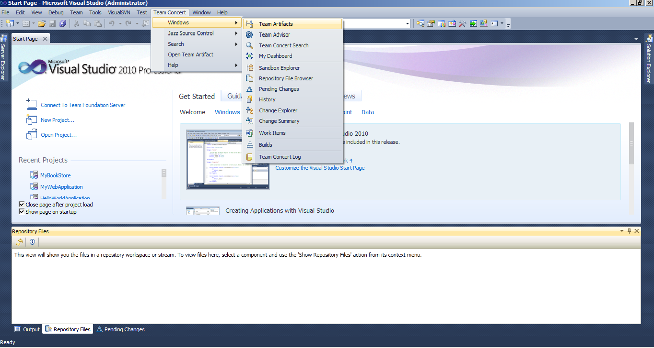

In **Team Artifacts view** 🡪 Click **Create New** **Repository Connection** 🡪 Enter the jazz server location path details along with your credentials and click ok

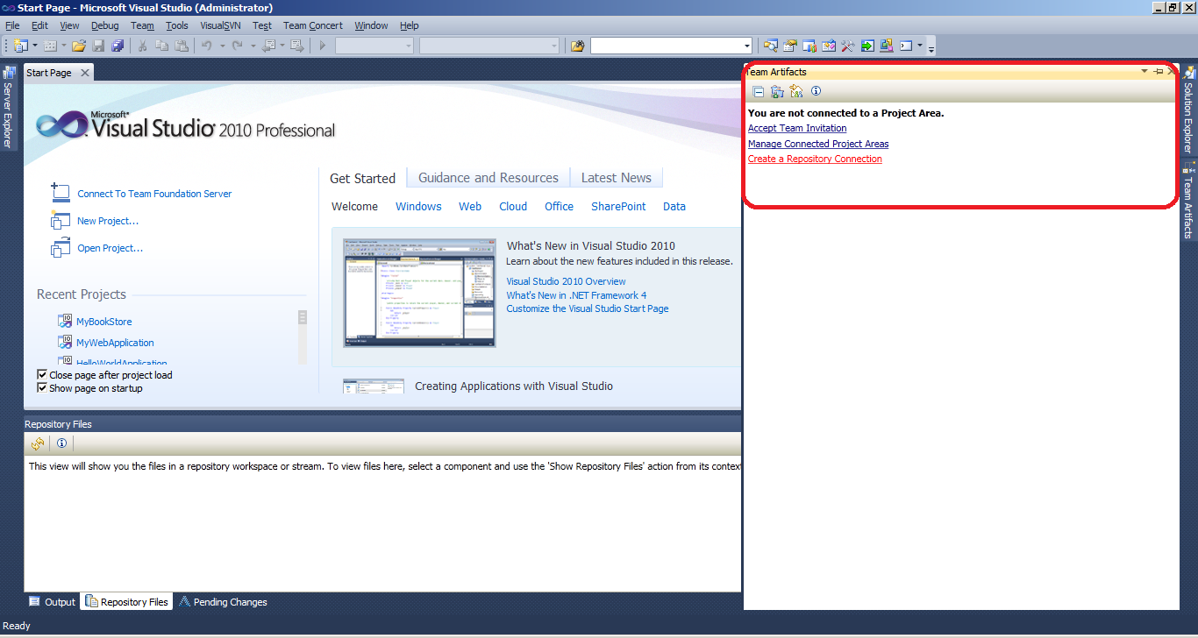

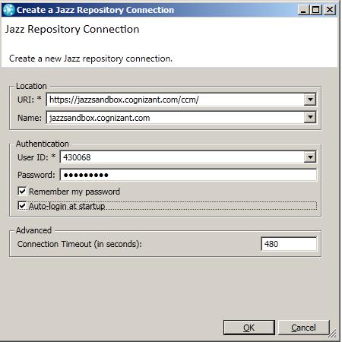

**Step 2:**

Import your project into RTC Visual Studio Client Version.

Right click on the **Repository**🡪Click **Manage Connected Project Areas**🡪Select your project from the list of projects🡪Click **Finish**🡪 RTC Project area is now available in Visual Studio.

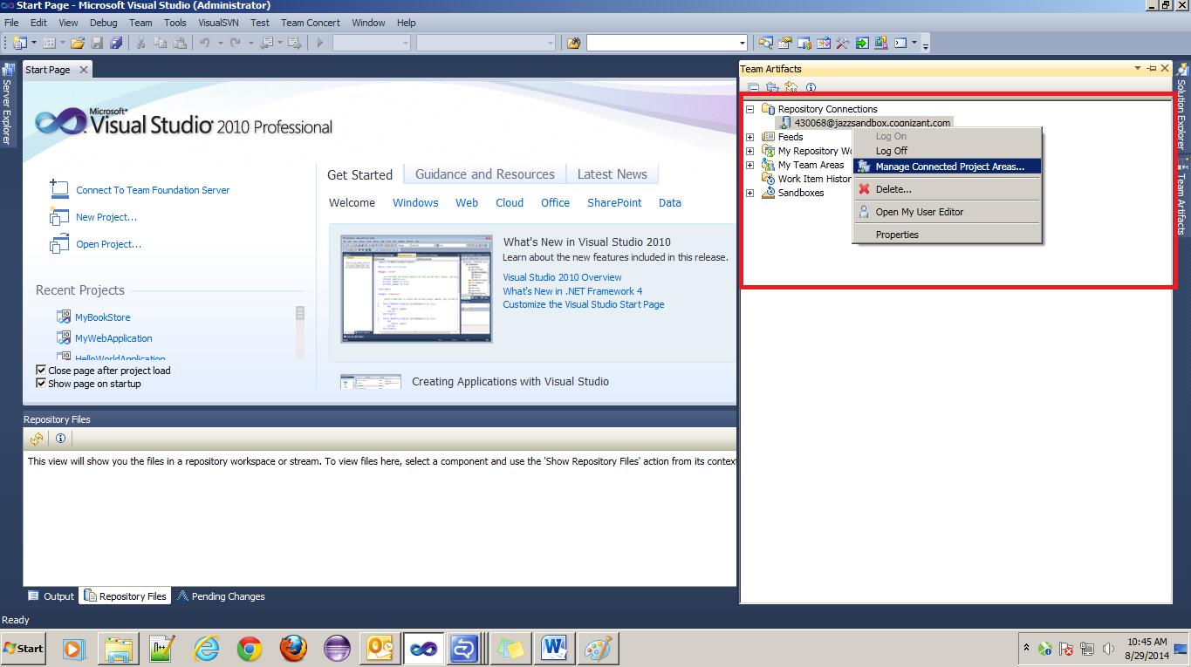

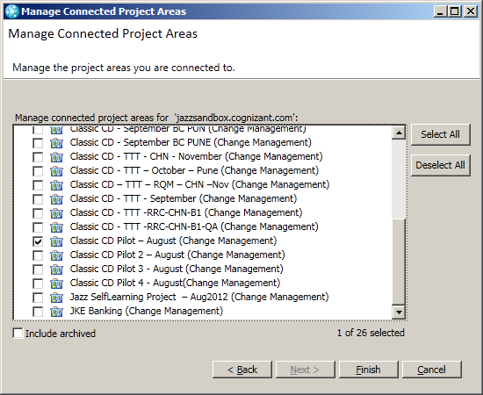

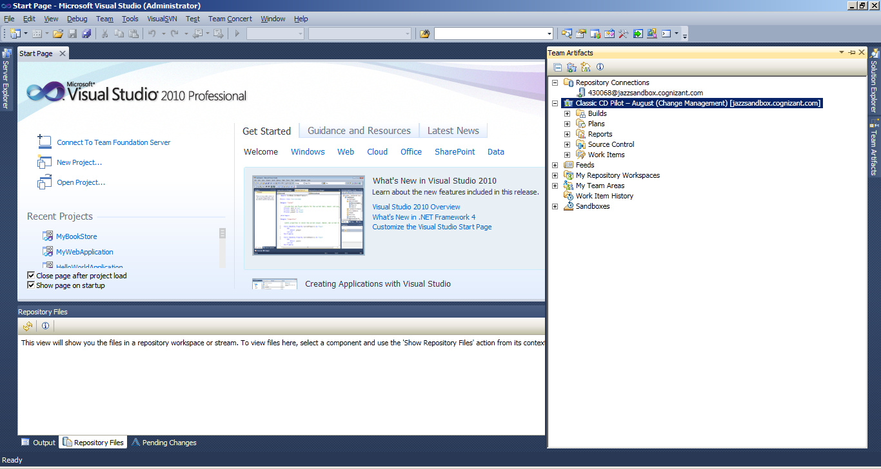

**Step 3:**

Create Build Definition Using Eclipse RTC Client

Connect to your Jazz project as you did in previous steps🡪Expand you project🡪Right click on **Build**🡪Click **New Build Definition**🡪 Select the Project area and Create new build🡪Click **Next**

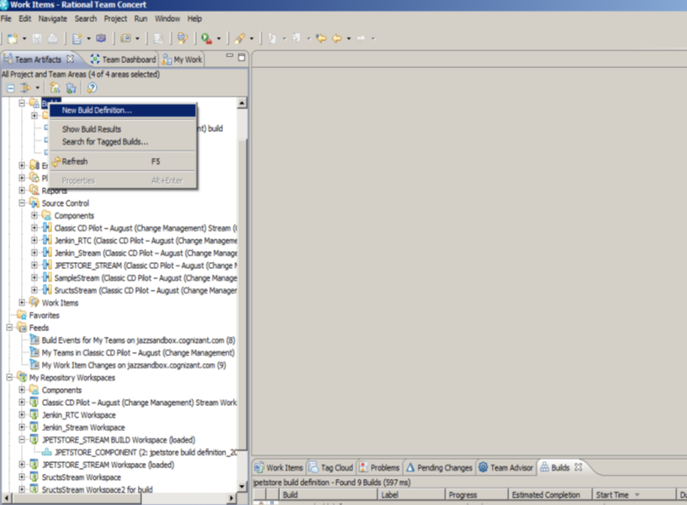

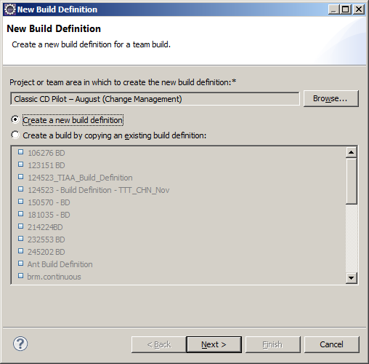

Give an **ID and Description🡪** Select the build Engine 🡪click **Next**

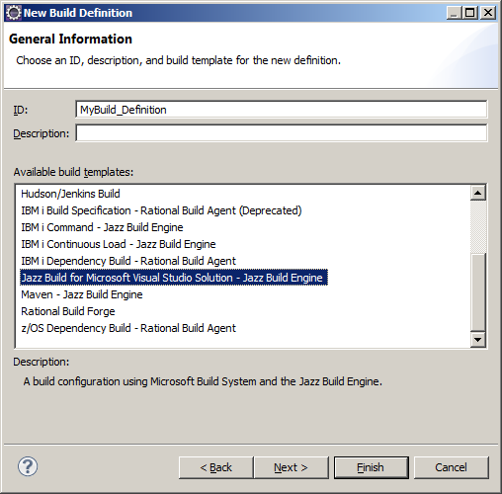

Check **Jazz Source Control 🡪** click **Next** 🡪 Select the Post Build Options(if required)🡪click Next🡪Select the default values🡪click finish.

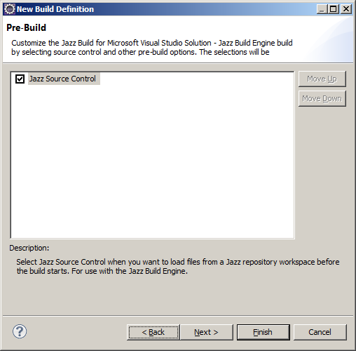 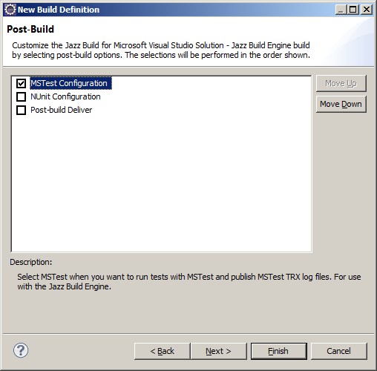

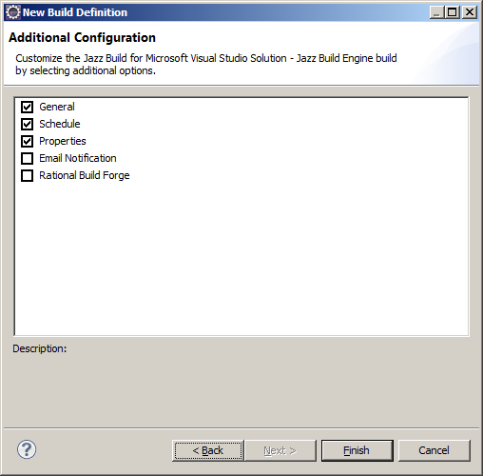

**Step 4:**

Create Build Engine

In the Overview page of Build Definition, under supporting build engines click **Create🡪**select **Jazz Build Engine🡪**click **Finish**

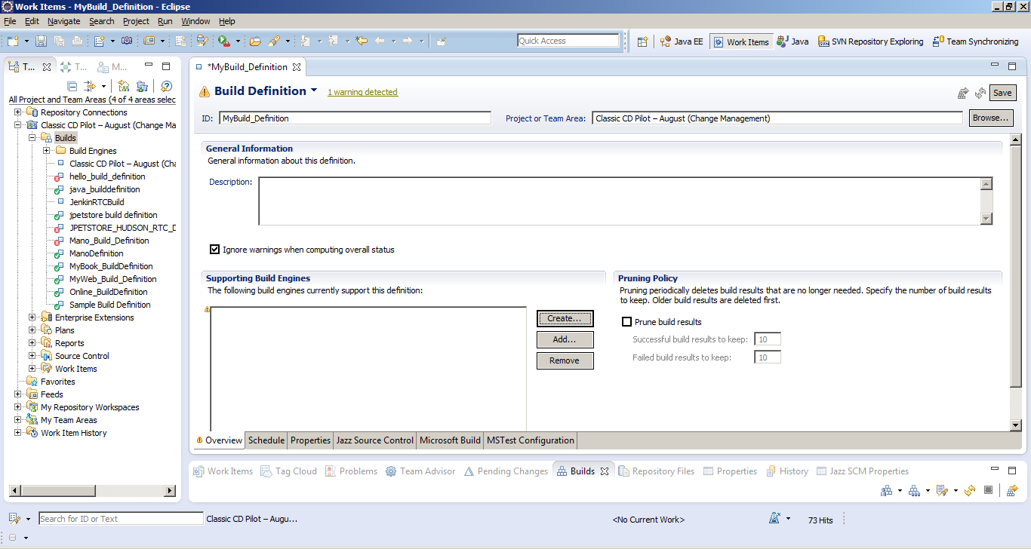

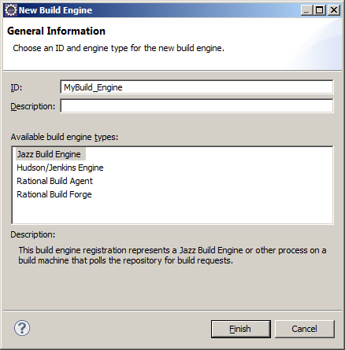

To schedule builds open schedule tab🡪under schedule pane check **Enabled🡪** click **Add** 🡪Set the **build** **time** and **build date** 🡪 Click **Save**

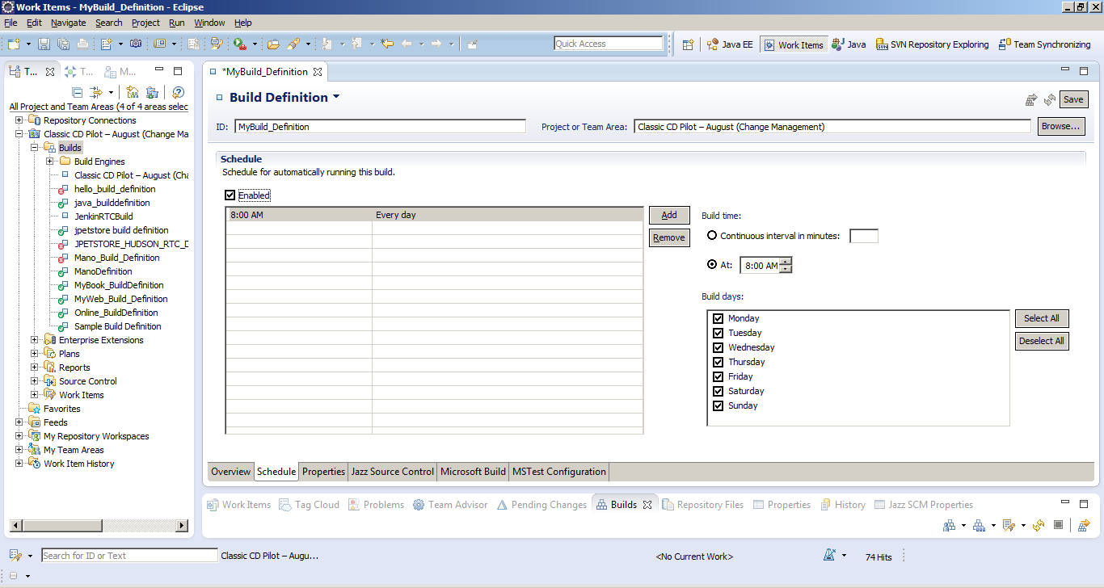

In **Properties tab**🡪 click **Add**🡪 give the name and path of the build directory

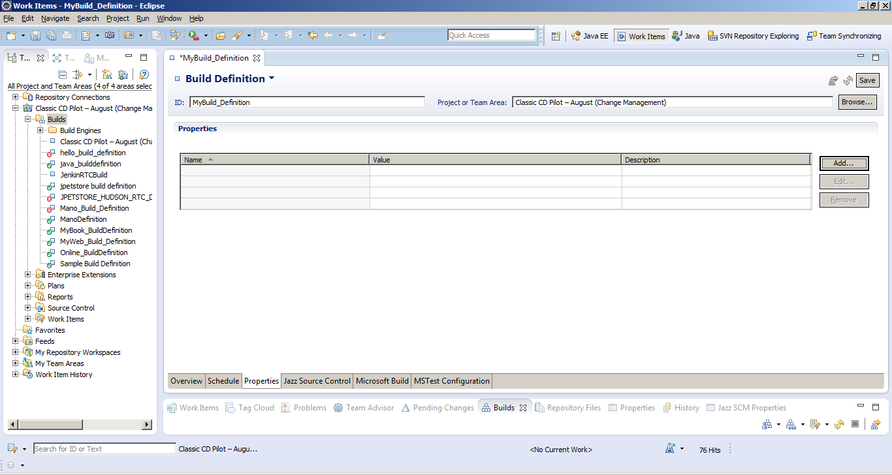

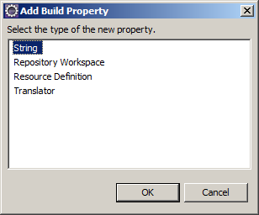 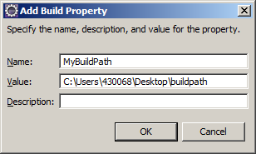

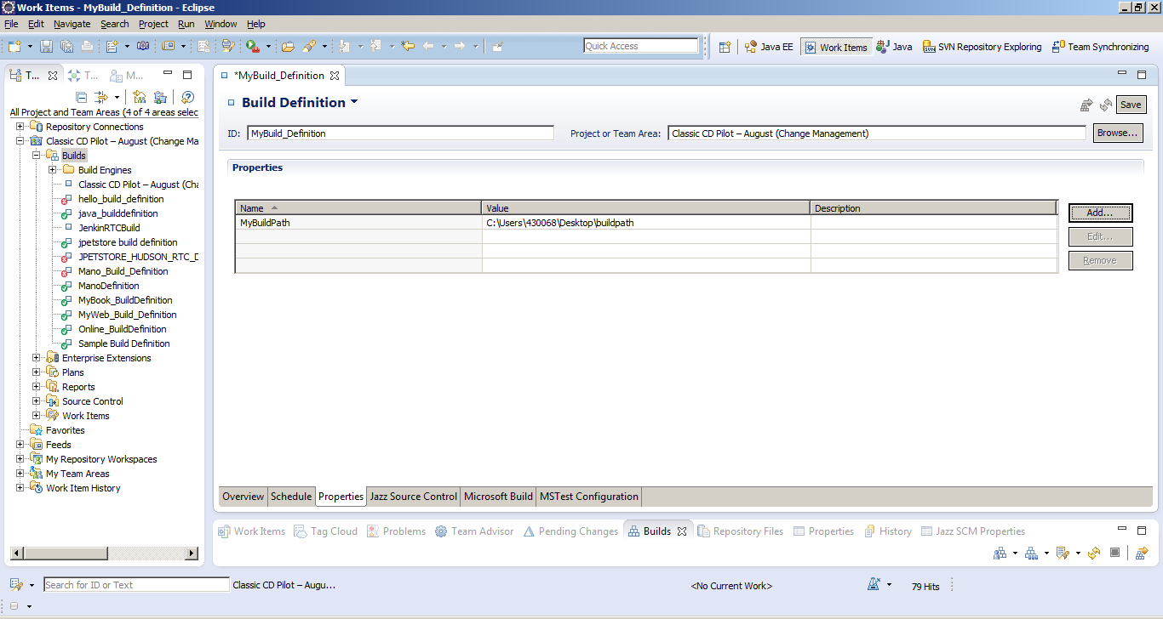

In **Jazz Source Control tab**🡪Browse and select the workspace (It is a best practice to have a dedicated build workspace)🡪 If you have a Workspace created earlier select the workspace or create the New Build Workspace

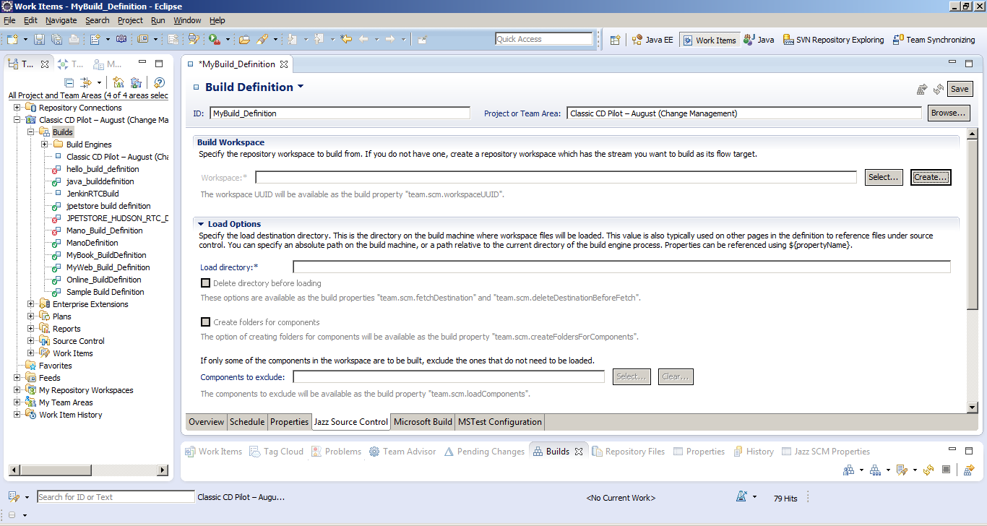

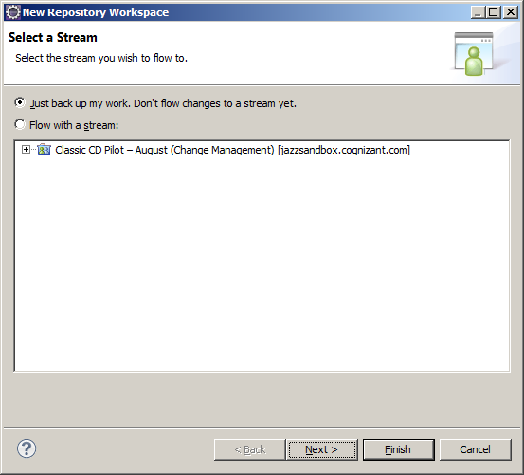 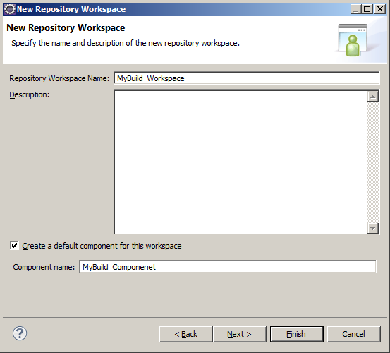

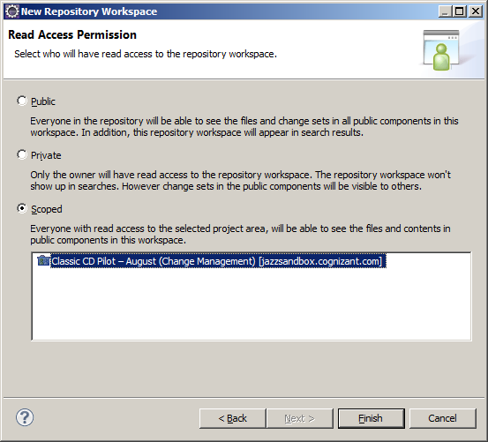

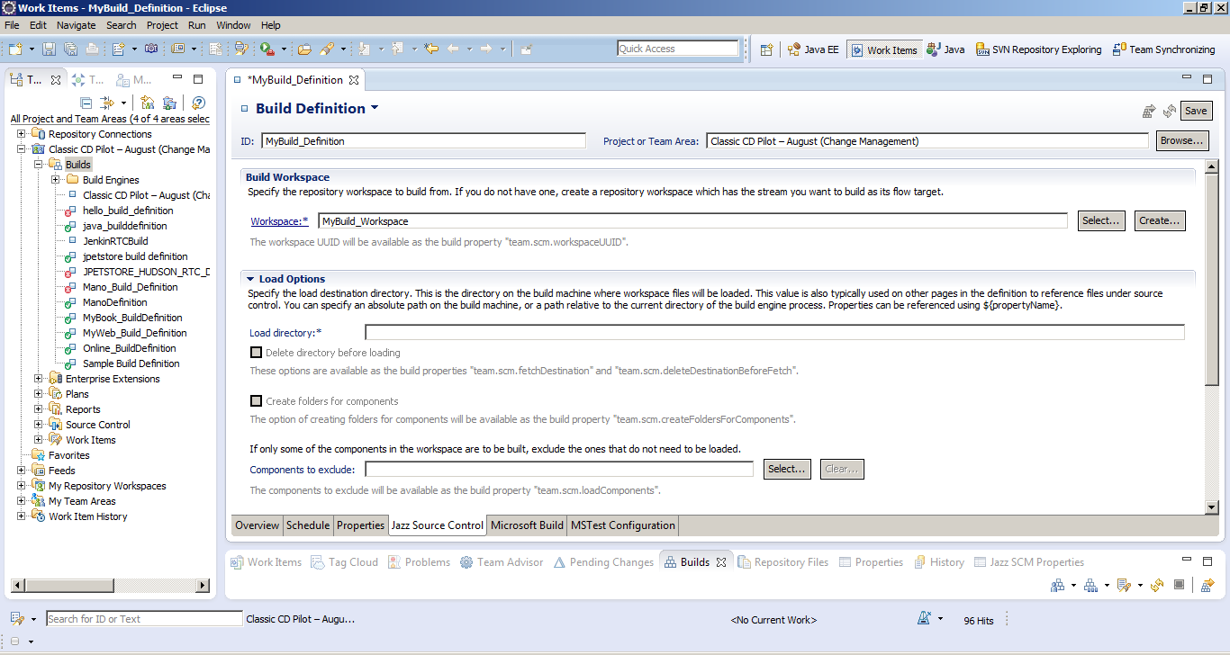

In the Load Options pane, in the Load directory field, type the path(which you have added in properties pane) to the directory on the build machine where workspace files should be loaded

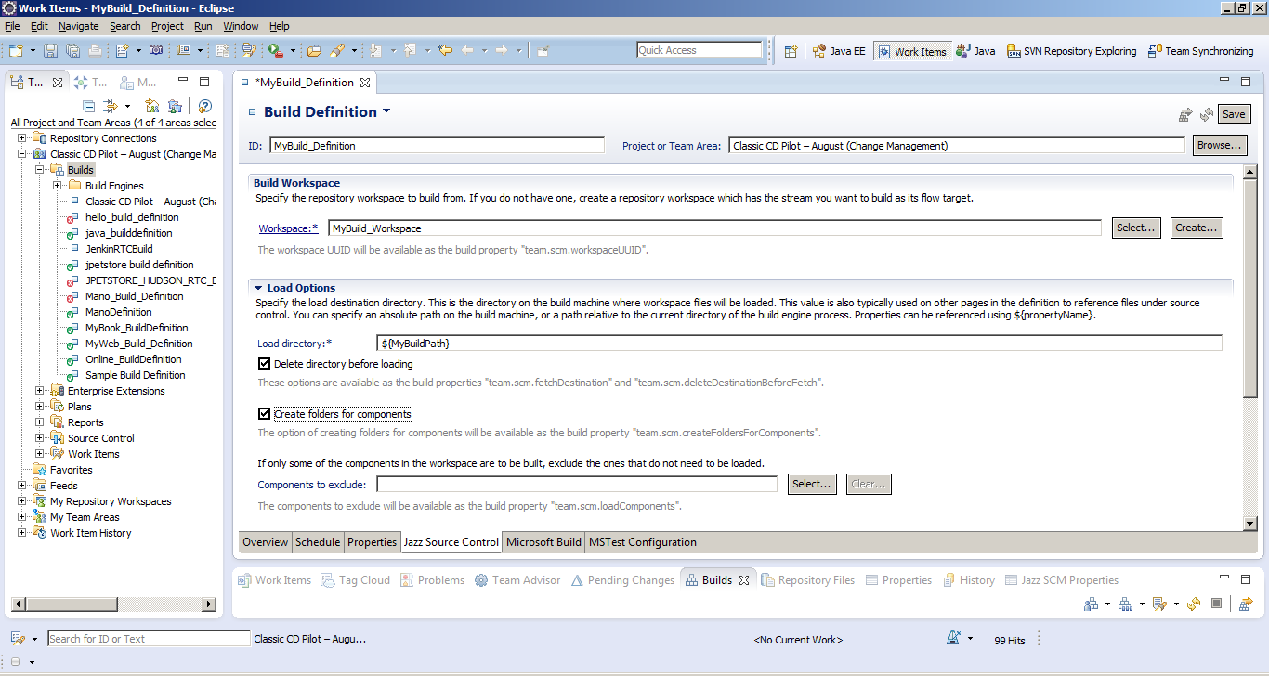

Under **Microsoft Build Tab**🡪 Select build command radio button select **MSBuild🡪**Give the **Path to Build command**

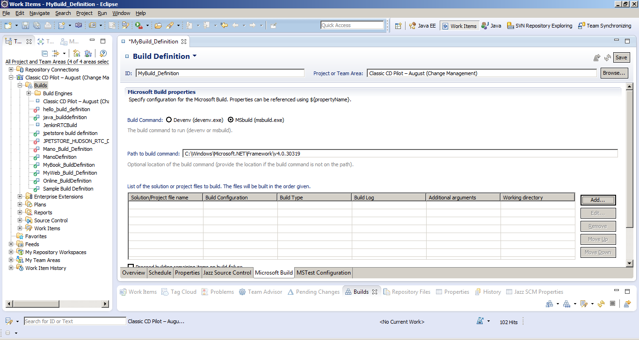

Click **Add button** to provide the **Solution File** of the .Net project to be built**, Build configuration, Build Type, build log(optional),Additional arguments(if required),Working Directory(optional)**



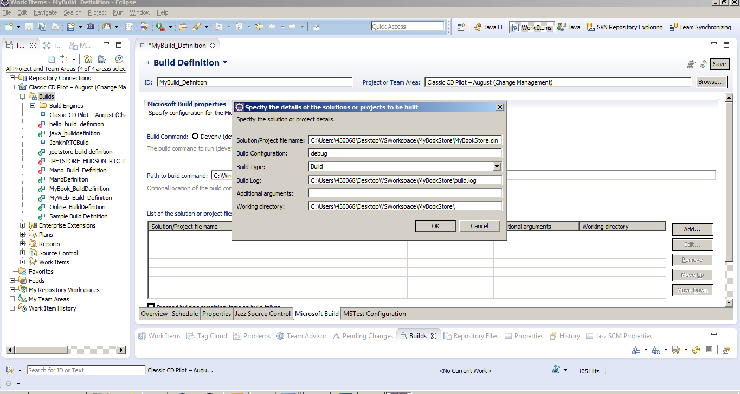

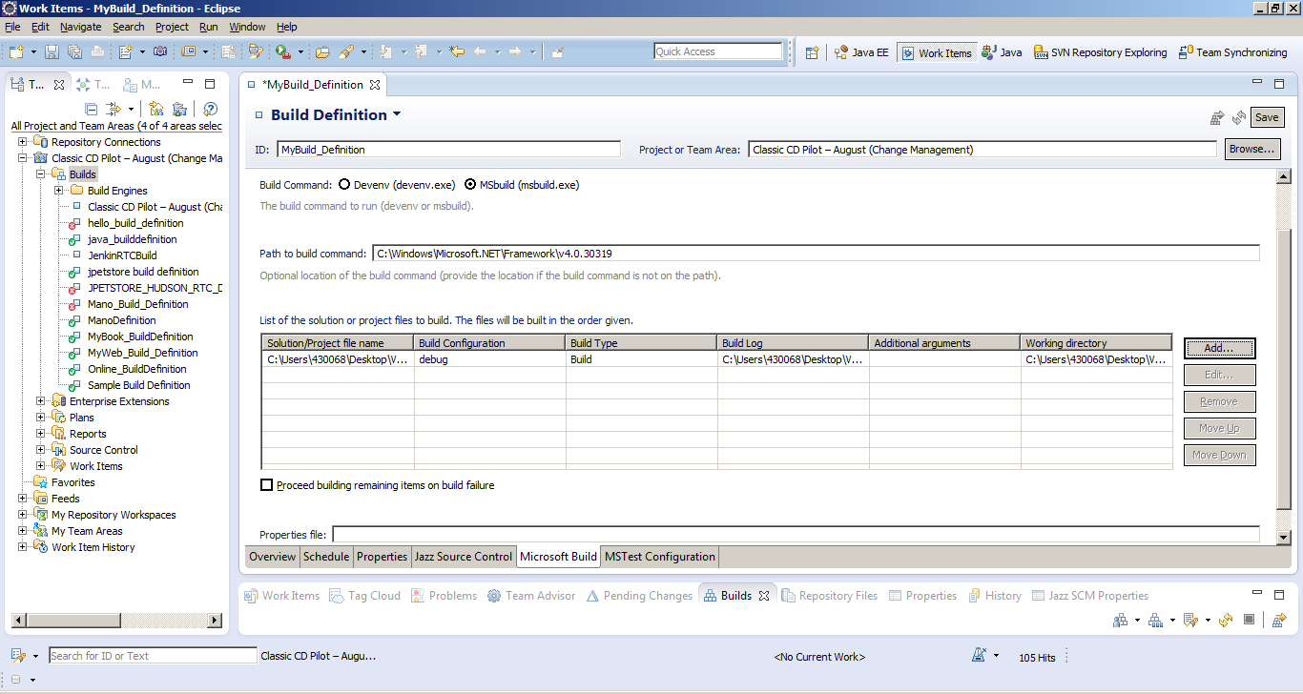

Under **MsTest Configuration Tab**🡪 give the **mstest.exe path** and **MsTest Specification file path** as shown🡪 Click **Save** To Save the Build Definition

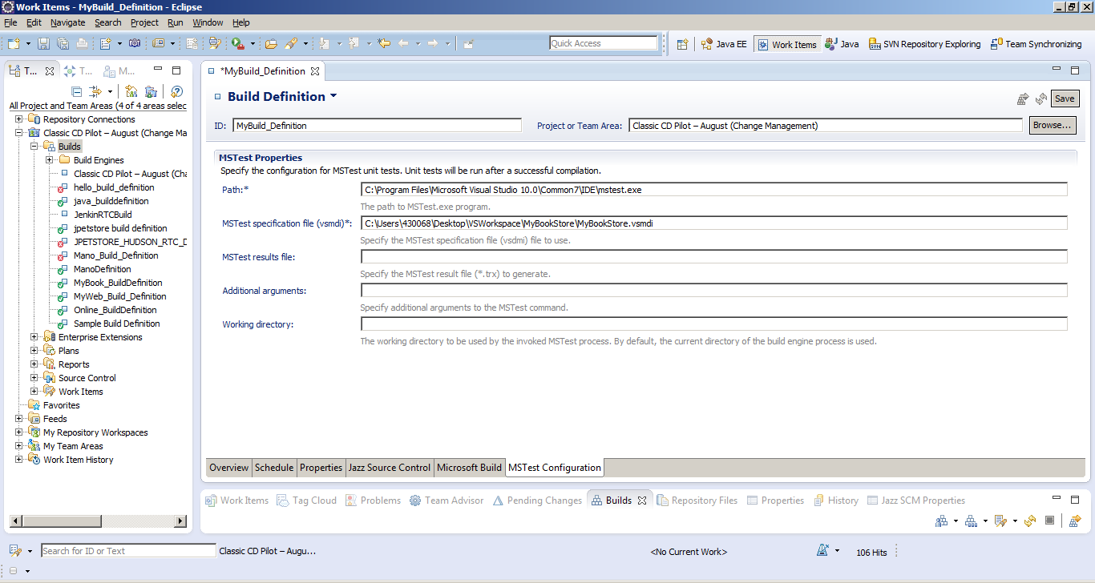

**Step 5:**

Start the Build Engine

To start the build engine:

1. From a command line, navigate to *installdir*/buildsystem/buildengine/eclipse, where *installdir* is the Build System Toolkit installation directory
2. Type jbe -vm *clientinstalldir*/jdk/bin/java -repository *repositoryURL* -userId build –pass *password* -engineId PreludeBuildEngine , where
   * *clientinstalldir* is the Jazz client installation directory.
   * *repositoryURL* is your repository URL. For example, <http://hostname.example.com/jazz/>.
   * Here *build* is the username
   * *password* is the build user's password.
   * *PreludeBuildEngine* is the engine id you created to execute the build.

**jbe -vm C:/progra~1/IBM/TeamConcertBuild/jre/bin/java -repository https://jazzsandbox.cognizant.com/ccm/ -userId 430068 –pass XXXXXX -engineId MyBuild_Engine**

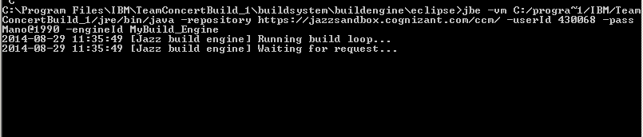

**Step 6:**

Build Request

In RTC Visual Studio client version in Team Artifacts view expand build folder under your project🡪Right click on the build definition🡪 Click **Request Build🡪 Click Submit**

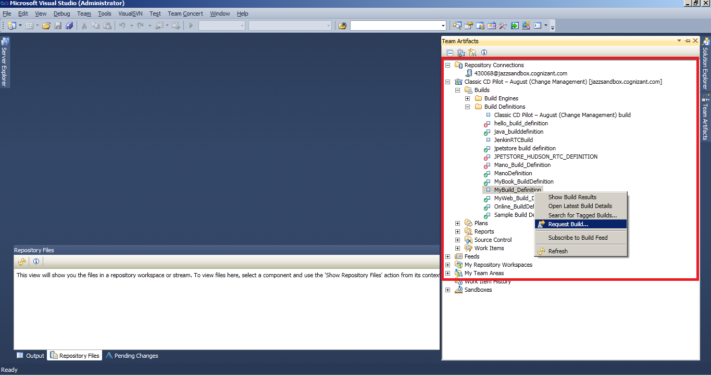

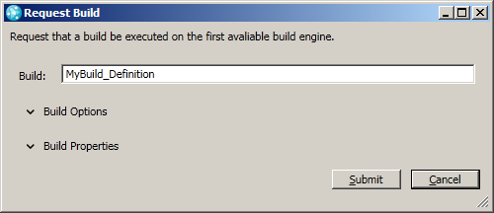

Build Progress can be viewed under build tab

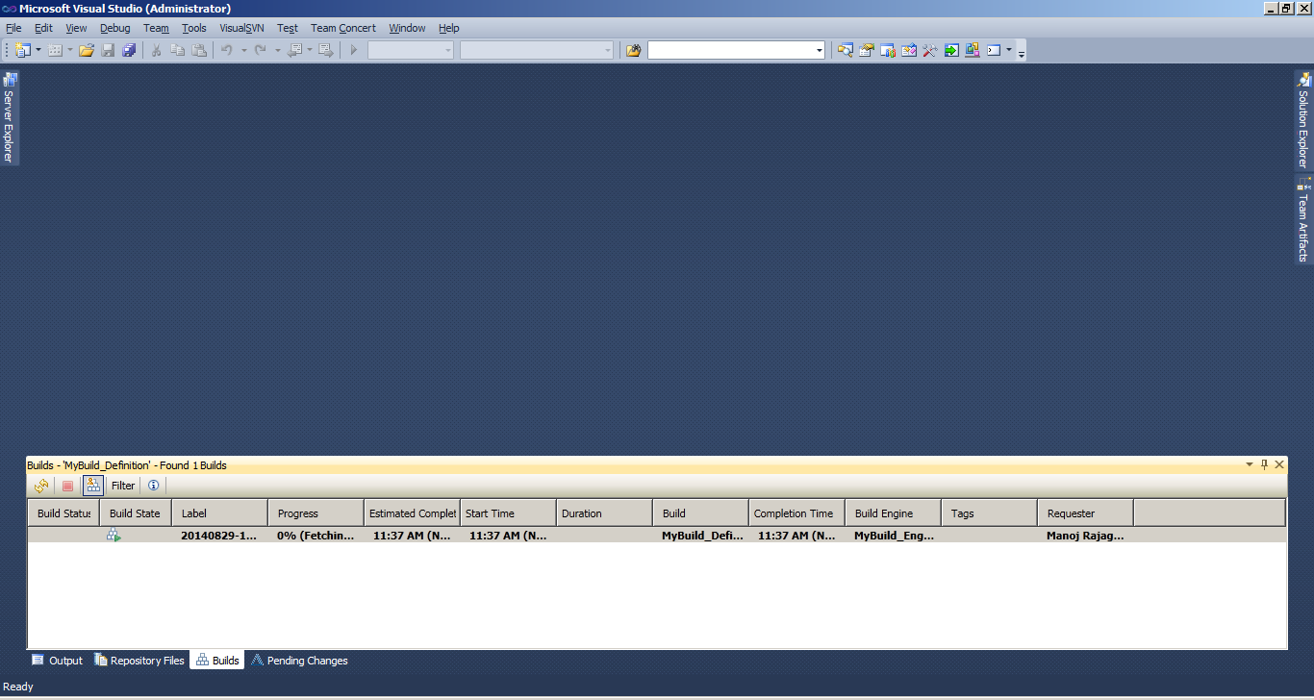

Build result will be showcased.

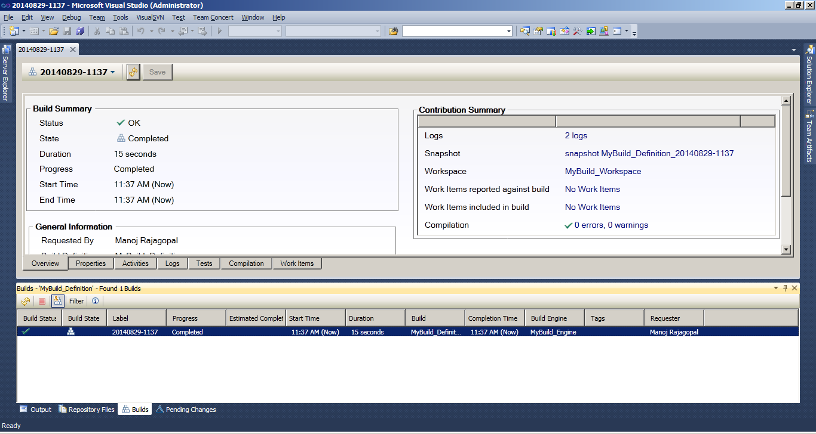

Personal Build  
To request a **personal build** 🡪 click **request build**🡪 under **build options**🡪check personal build and mention your build workspace and click submit

